**SOFTWARE CONSTRUCTION 2**

**LAB PREPARATION**

**5**

**BY**

**EMMANUEL DURU**

**MATRIC NUMBER: 2502665**

**GROUP 32**

**PROFESSOR WOLFGANG RENZ**

**(A and B - show concepts):**

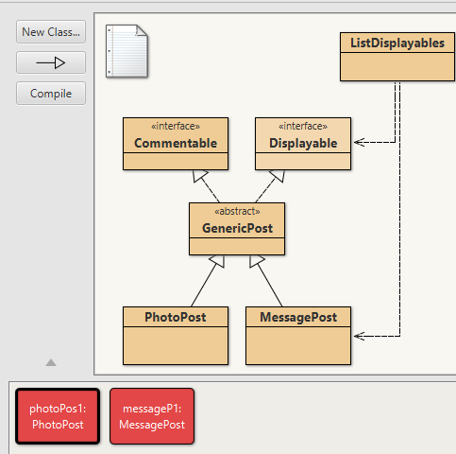

**In which of the classes you find a polymorphic list?**:

The instant variables of photoPost and messagePost are inherited from the GenericPost and that is where i found the polymorphic.

**which are the dynamic types when filled and the static?:**

Dynamic types when filled are the photoPost and messagePost and static type is the GenericPost class as understood from the given classes

**What "is-a" relations are given by the class diagram here?:**

From the diagram I was able to note that the “is-a” is basically the generic class because the functionality of the other classes are been dependent on the Generic class.

**Which classes contain an implementation of a display method?:**

The classes of photoPost and messagePost contains the display method

**What is the difference to *network-v4* and what is the improvement in *v5* at what cost:**

The improvement is that our network v5 has a sub-class of the displayable and commentable classes while network v4 does not have those sub-classes

**(A and B - interface):**

1. I created a new Ipowerplant class interface which was done on a reference from the LAB2 task
2. I deleted the method inside to sure it becomes an interface of the other classes
3. I went to the the powerplant class to implement the IpowerPlant class by “implement IpowerPlant”

I clearer description is given with the file attached to this.